**DEATH RATE AND CONTRIBUTORY FACTORS**

**INTRODUCTION**

Death rate is an important demographic indicator that reflects the number of deaths per unit of population in a given time frame. Understanding death rates can provide crucial insights into a region's overall health status and the quality of its healthcare system. While the global death rate has been declining over the years, certain regions and countries still face challenges in reducing their death rates. One such region is Africa, and within it, Nigeria stands out as one of the countries with a relatively high death rate. Understanding the factors that contribute to these death rates can provide insights into how to address the death rates in the world, Africa, and Nigeria, as well as the various factors that contribute to them. From the burden of infectious diseases to the impact of non-communicable diseases, we will examine the social, economic, and environmental factors that influence mortality rates in these regions which can help can help shed light on the global health landscape and the specific challenges that these regions face in terms of health and healthcare, and also highlight potential strategies for improving health outcomes.

**METHODOLOGYTop of Form**

The data used for this analysis is collected from Kaggle. The data includes information on the names of countries/region, number of deaths caused by different factors such as unsafe sanitation, unsafe sex, drug and alcohol abuse, malnutrition, lack of water facilities/pollution, vitamins & mineral deficiency, infant/ child stunting, air pollution, obesity.

This data contains estimated deaths resulting from the causal factors listed above in Africa from 1990 to 2017.

The data is updated regularly to reflect the latest information on the total mortality rate worldwide.

**ANALYSIS**

DASHBOARD 1

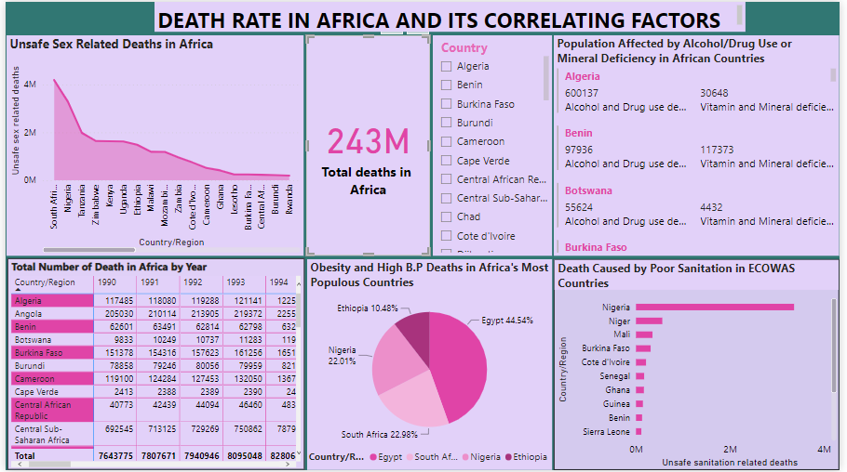

CHART 1:

This chart analyzes the number of deaths resulting from unsafe sex in African countries from 1990 to 2017. The country with the highest number of deaths caused by unsafe sex in Africa is South Africa with a total of about 4,192,176 million cases and the country with the lowest number of cases is Rwanda with the total number of recorded cases as 196,780 thousand cases. 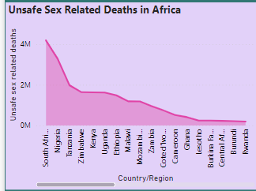



According to the World Health Organization, unsafe sex is a major contributor to deaths in Africa, particularly among young people aged 15-49. In 2019 alone, an estimated 190,000 thousand people died from AIDS-related illnesses in the region. Additionally, unsafe abortions account for a significant proportion of maternal deaths. Lack of access to comprehensive sexual and reproductive health services, including contraception, is a key factor driving these deaths.

CHART 2:

This type of chart is called a card. It shows the total number of recorded deaths in Africa which is 243 million deaths.

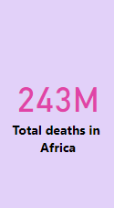

According to data, the total number of deaths in Africa between 1990 and 2017 has been on a steady rise. In 1990, the total number of deaths in Africa was approximately 8 million, and continued to rise till it reached its peak of about 9.3 million cases and the started a downwards trend till in 2017, the number had gotten to approximately 7.9 million cases.

The leading causes of death in Africa during this period were HIV/AIDS, lower respiratory infections, and diarrheal diseases. Other major causes of death included malaria, tuberculosis, and neonatal disorders.

CHART 3:

This chart creates a comparison between the number of deaths caused by alcohol and drug abuse to deaths caused by mineral deficiency. However, Drug abuse can impact the body's ability to absorb and utilize nutrients properly, leading to deficiencies in essential minerals such as magnesium, zinc, and potassium. These mineral deficiencies can cause a range of symptoms, including muscle weakness, fatigue, and irregular heartbeat, which can increase the risk of death.

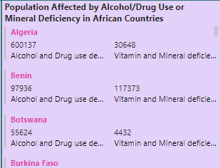

CHART 4:

This table shows the total number of deaths recorded in each African country by year. From the year 1990, the number of total recorded deaths in Africa began to rise until it reached its peak in 2001 with a total of 8,997,621 million recorded cases after which the numbers started to flatline.

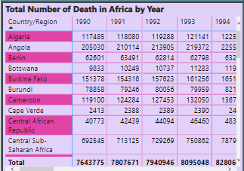

CHART 5:

According to the WHO, high blood pressure is a leading cause of death worldwide. This chart examines high blood pressure deaths in Africa's most populous countries, we look at data for Nigeria, Ethiopia, Egypt and South Africa. These four countries are the most populous in Africa and together account for about 45% of the continent's population.

The estimated number of deaths caused by high blood pressure and related conditions in Nigeria was 2,533,700 million deaths. In Ethiopia, it was 1,206,180 million deaths In South Africa, it was 2,645,462 million deaths while in Egypt, it was 5,128,628 million estimated deaths.

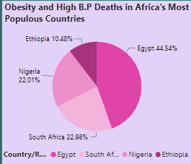

CHART 6:

The Economic Community of West African States (ECOWAS) is a regional economic union in West Africa that includes 15 member states. Poor sanitation is a significant public health issue in many of these countries, leading to increased rates of diarrheal diseases, cholera, and other waterborne illnesses. The country with highest amounts of death resulting from poor sanitation is Nigeria with a total of 3,360,283 million cases.

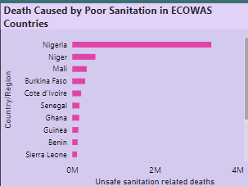

DASH BOARD 2:

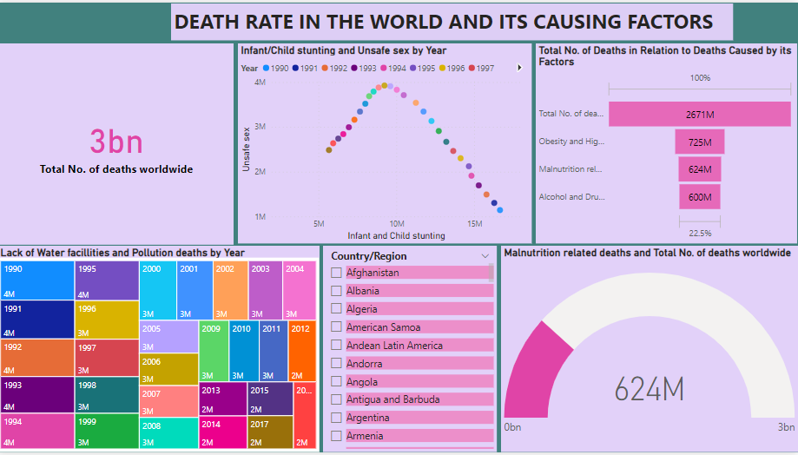

CHART 1:

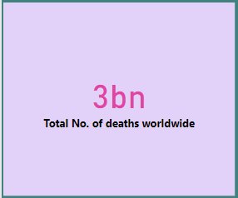

Total deaths worldwide is a complex and constantly changing statistic, influenced by a variety of factors such as demographics, health care, and environmental conditions. the continent that made up the most percentage of world deaths between 1990 and 2017 was Asia. In 2017, Asia accounted for 61.4% of global deaths. This was followed by Africa, which accounted for 23.4% of global deaths, and then by Europe, which accounted for 8.5% of global deaths. North and South America accounted for 6.1% and 1.2% of global deaths, respectively.

CHART 2:

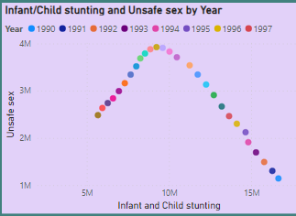

This chart is called a Scatter plot. In this plot we compare the relationship between unsafe sex and child stunting deaths. As the number of deaths from unsafe sex increases so does the number of infant or child mortality deaths. The analysis suggests that there is a significant relationship between unsafe sex and child stunting. Mothers who have unsafe sexual are more likely to have a stunted child.

CHART 3:

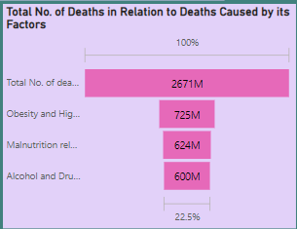  
This chart is a funnel chart. In this chart we analysed the number of deaths caused by obesity and high blood pressure, malnutrition and Alcohol/ drug abuse related deaths and compared them to each other in percentages. This chart also compares each of these deaths against the total number of deaths recorded. Alcohol and drug abuse makes up about 22.5% of the total estimated deaths worldwide. Malnutrition related death take up about 23.4 %

CHART 4:

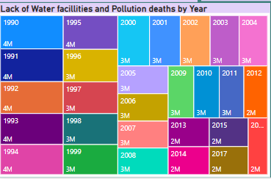

The above chart shows the distribution of water pollution related deaths in the world by year. This type of chart is a Tree map chart. The number of deaths from water pollution related factor recorded its highest number of cases in the early 1990’s and then started a gradual trend of decrease in number of deaths and by 2012 it had fallen to about 50% of its original number.

CHART 5:

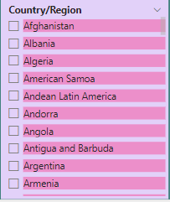

This chart is a slicer. It has been created to choose what countries information we want to analyse. It helps to quickly refine the data shown on the dashboard by choosing a country of choice. It can be used to filter data by a single column or multiple columns of a dataset.

CHART 6:

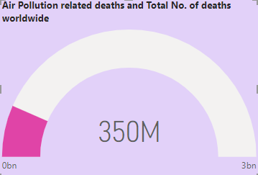

This chart shows much of Air pollution related deaths make up the total recorded deaths worldwide. Out of the estimated 3 billion worldwide deaths, Air pollution is responsible for 350 million deaths which makes up about 13.2% of the total recorded deaths.

DASHBOARD 3:

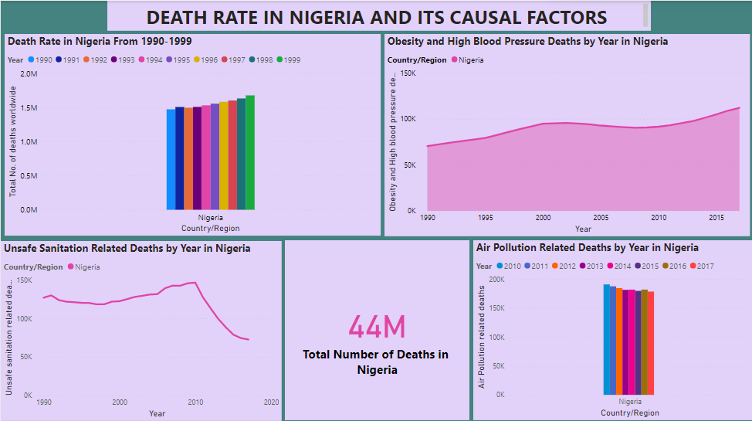

CHART 1:

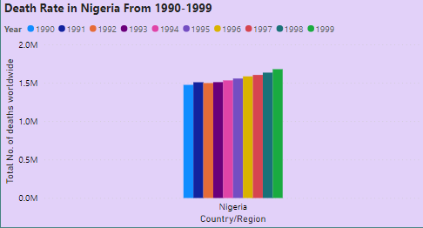

This chart analyses the number of deaths recorded in Nigeria in each year from 1990 to 1999. The number of recorded deaths gradually increases each year till it hits its highest recorded deaths in 1999.

CHART 2:

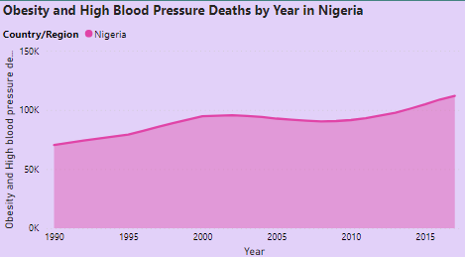

This chart is an area chart. From the plot we notice that the number of deaths stemming from obesity and high blood pressure increases steadily till the year 2002 when it reaches a total of 95,542 thousand and then begins to flatline till the year 2008 at which point it begins to rise again till it reaches a total of 112,006 thousand recorded deaths in 2017.

CHART 3:

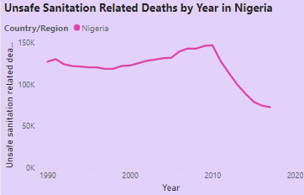

This cgart analyses the total number of deaths stemming from unsafe sanitation in Nigeria. Between 1990 and 1991 we notice a shortlived spike in the number of recorded death with an increase of 3000 deaths. From 1991 to 1998 the number of deaths trend downwards, after which it begins to increase again til it reaches its peak in 2010 with a total of 146,405 deaths. From that point till 2017 we notice a sharp downwad trend in recorded deaths.

CHART 4:

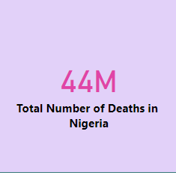

According to the World Health Organization, Nigeria had a death rate of 12.4 deaths per 1,000 people in 2020. This rate has been steadily decreasing over the past few years, with a 25% decrease since 2000. However, Nigeria still has one of the highest death rates in sub-Saharan Africa. The leading causes of death in Nigeria include malaria, HIV/AIDS, and lower respiratory infections. Addressing these health challenges through targeted interventions, improved healthcare systems, and increased public health education could further reduce the country's death rate.

CHART 5:

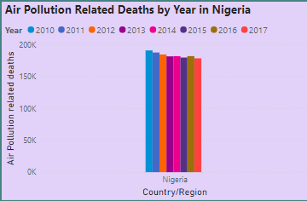

This chart shows the number of deaths caused by air pollution in Nigeria from 2010 to 2017. The total number of deaths stand at 190,690 thousand in 2010 after which the death toll gradually reduces each year till it reaches a total of 178,342 thousand in 2017.

**CONCLUSION**

The leading causes of death in Africa during this period were HIV/AIDS, lower respiratory infections, and diarrheal diseases. Other major causes of death included malaria, tuberculosis, and neonatal disorders.

It is worth noting that there have been some improvements in health outcomes in Africa over the years. For example, the mortality rate for children under the age of five decreased from 176 deaths per 1,000 live births in 1990 to 78 deaths per 1,000 live births in 2017. Similarly, the number of deaths due to HIV/AIDS has decreased in recent years due to the availability of antiretroviral therapy.

However, much work still needs to be done to address the high burden of disease in Africa. Improving access to healthcare services, implementing effective prevention and treatment programs, and investing in research to address the underlying causes of these diseases are all crucial steps in reducing the number of deaths in Africa and improving overall health outcomes.

**RECOMMENDATION**

To fix the high death rate in the world, a comprehensive and collaborative approach is needed. This approach should prioritize public health measures such as increasing access to healthcare, improving sanitation and hygiene, promoting healthy lifestyle choices, and implementing policies to reduce environmental pollution and unsafe working conditions. Governments and international organizations must invest in research and development to address the unique health challenges facing populations worldwide. Additionally, it is crucial to prioritize equitable access to healthcare and resources, as well as address systemic inequalities that contribute to health disparities. By taking these steps, we can work towards reducing the global death rate and improving health outcomes for all people.